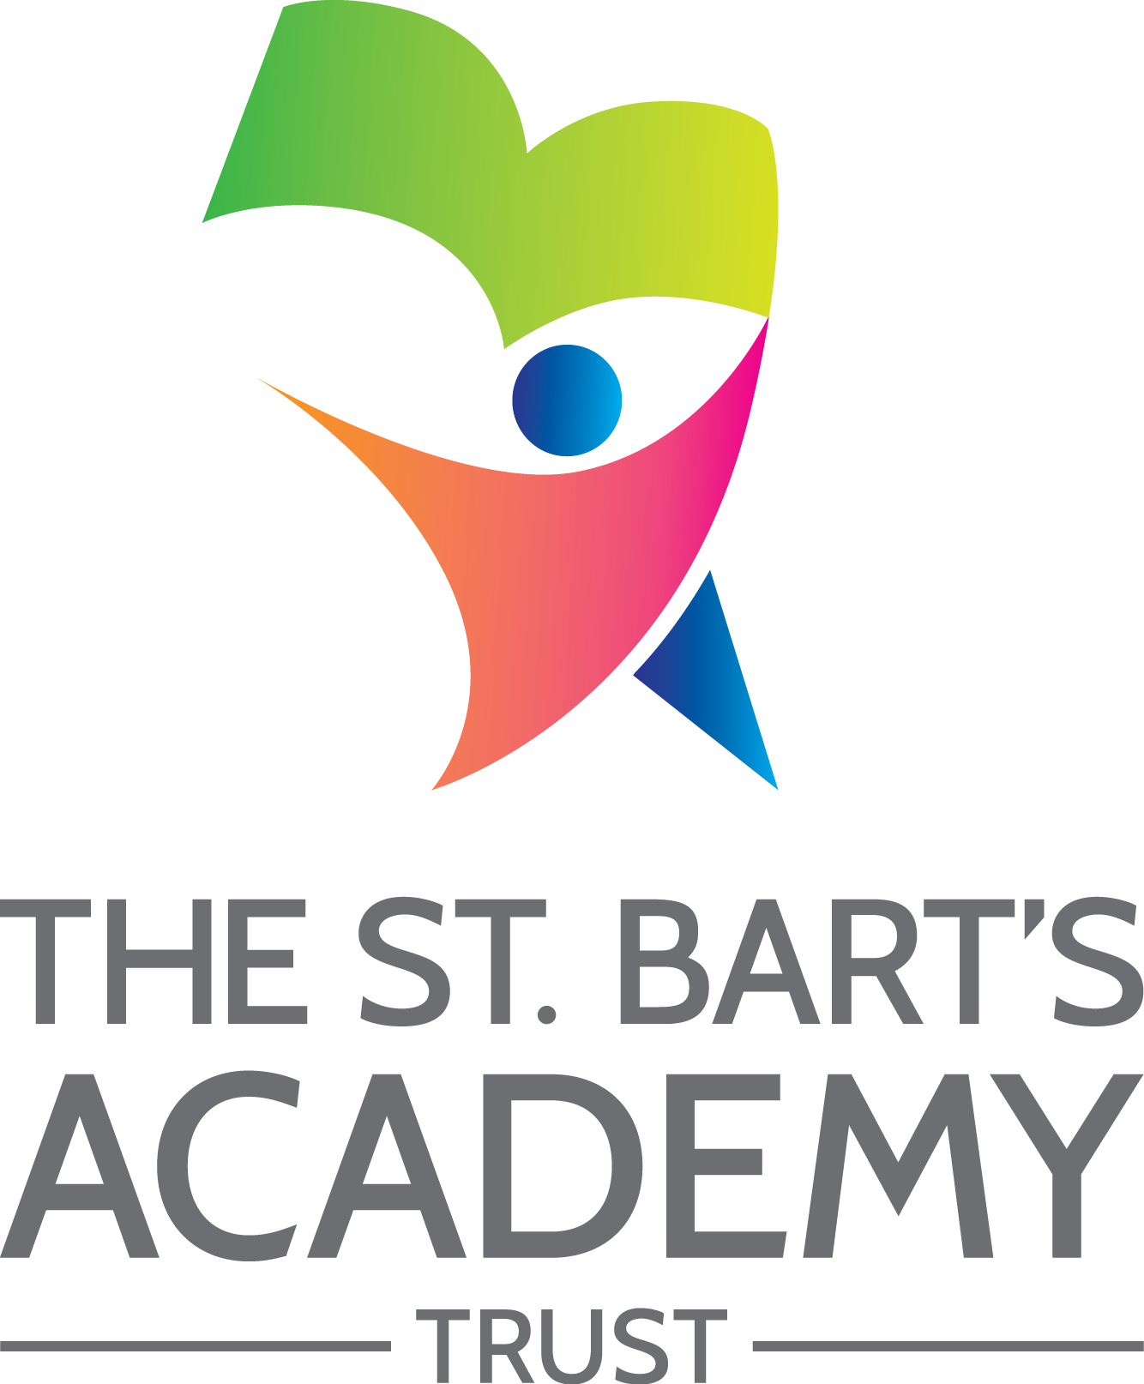

Knutton St. Mary's CofE Academy

Accessibility
Plan

October 2024

The St. Bart’s Academy Trust
Accessibility Plan
Date | Section Amended | Signature
01/03/2023 | TSB Policy Adopted – v4 | S. Jones
01/09/2026 | Actions reviewed and plan updated | C. Tomlinson/C.Wright



Contents

Statement of intent 4
1. Accessibility Plan – 2026 / 2027 5
2. Planning Duty 1: Curriculum 6
3. Planning Duty 2: Physical Environment 7
4. Planning Duty 3: Information 8

Statement of intent
This plan outlines how Knutton St. Mary's CofE Academy aims to increase access to education for pupils with disabilities in the three areas required by the planning duties in the Equality Act 2010 (i.e. the curriculum, physical environment and information).
A person is regarded as having a disability under the Equality Act where they have a physical or mental impairment that has a substantial and long-term adverse effect on their ability to carry out normal day-to-day activities.
This plan aims to:
- Increase the extent to which pupils with disabilities can participate in the curriculum.
- Improve the physical environment of the school to enable pupils with disabilities to take better advantage of education, benefits, facilities and services provided.
- Improve the availability of accessible information to pupils with disabilities.
The above aims will be delivered within a reasonable timeframe, and in ways which are determined after taking into account pupils’ disabilities and the views of parents and pupils. In the preparation of an accessibility strategy, the LA will have regard to the need to allocate adequate resources in the implementation of this strategy.
The governing committee also recognises its responsibilities towards employees with disabilities and will:
- Monitor recruitment procedures to ensure that individuals with disabilities are provided with equal opportunities.
- Provide appropriate support and provision for employees with disabilities to ensure that they can carry out their work effectively without barriers.
- Undertake reasonable adjustments to enable staff to access the workplace.
- The plan will be resourced, implemented, reviewed and revised in consultation with:
- Pupils’ parents.
- The principal and other relevant members of staff.
- Governors.
- External partners.

- Accessibility Plan – 2026-2027 (year 3 of 3-year strategy 2024-2027)
Our Accessibility Plan sets out how this Academy will improve equality of opportunity for disabled people. This plan sets out the establishment’s proposals to increase access to education for disabled pupils in the following three areas:
- Increasing the extent to which disabled pupils can participate in the curriculum on an equal basis with their peers;
- Improving the physical environment of the establishment to enable disabled pupils to take better advantage of education and associated facilities and services; and
- Improving the availability of accessible information to disabled pupils.
The preparation of the Accessibility Plan has been informed by audits and analyses of data within the Academy and its premises. It is a requirement that the Accessibility Plan is resourced, implemented and reviewed as necessary and at least annually. A copy of this Plan together with the SBMAT Accessibility Policy will be placed upon our website.
This plan will be reviewed on an annual basis by the Local Governing Committee and Principal. Any changes to this plan will be communicated to all staff members and relevant stakeholders.

- Planning Duty 1: Curriculum
Issue / action | Lead / resources | Target date | Success criteria
Embed the High-Quality Teaching and Learning pupil entitlement across the whole curriculum.  Specify non-negotiable inclusive teaching approaches; review implementation termly through learning walks, planning scrutiny and pupil voice. | SLT  Resources: CPD time  CPD programme; subject-leader monitoring time; adaptive teaching resources. | Ongoing  Termly reviews; annual evaluation July 2027. | All pupils experience high-quality teaching and make at least expected progress; some make accelerated progress.  Monitor progress by pupil group (including SEND and disadvantaged pupils); evaluate quality of teaching and the proportion making expected or better progress.
Increase pupil participation in extracurricular activities.  Prioritise pupils with SEND, disadvantaged pupils and those who have not previously participated; remove barriers to access. | SLT  Resources: Not specified  Club staffing; accessible provision; transport or subsidy funding where required. | Ongoing  Participation reviewed each term; July 2027 evaluation. | Greater numbers of pupils attend after-school clubs.  Set a baseline and improve participation and sustained attendance, with narrowing gaps between pupil groups.
Ensure every pupil can take part in educational visits.  Publish a progressive whole-school visits map; assess accessibility and reasonable adjustments at the planning stage. | Class teachers  Resources: Not specified  Visit budgets and subsidies; accessible transport; staffing and risk-assessment time. | Ongoing  Annual map approved by autumn term; termly monitoring. | A mapped programme of visits across year groups, providing equitable opportunities and explicit curriculum links.  All year groups have planned curriculum-linked experiences; non-participation and access barriers are identified and addressed.
Prepare resources and scaffolds to enable pupils to access the curriculum, including visual timetables and now-and-next cards.  Agree a graduated, needs-led approach to scaffolding; review effectiveness and promote independence rather than permanent over-support. | Class teachers  Resources: Not specified  Planning/preparation time; visual resources; assistive technology as appropriate; SENCO support. | Ongoing  Provision audited termly; individual reviews each term. | Barriers to learning are reduced, pupils access the full curriculum, and they make at least expected progress.  Adaptations are available where needed and demonstrably improve participation, independence and progress.
Review school policies and schemes of work to address disability, inclusion and specific needs.  Reference Equality Act 2010 duties, reasonable adjustments and SEND requirements; involve governors, pupils and families in review. | SLT  Resources: Release time  SLT/subject-leader release time; governor oversight; specialist advice where needed. | Ongoing  Policy review cycle agreed by December 2026; annual check. | Policies reflect disability-related duties and the needs of pupils in the school.  Relevant policies and curriculum documentation are updated, approved, communicated and reflected in practice.
Use personalised individual learning plans (ILPs) for pupils receiving SEN Support and those with EHCPs, with pupils and parents co-producing SMART outcomes.  Use a consistent assess–plan–do–review cycle; align EHCP provision and outcomes; record pupil/parent voice and intervention impact. | Class teachers / SENCO  Resources: Release time  Teacher and SENCO release time; review meetings; specialist agency input where required. | Ongoing  Review at least termly; statutory EHCP annual reviews. | Progress is regularly analysed; pupils at risk of falling behind are identified and timely actions are taken.  Plans contain measurable outcomes, are reviewed on time, and show improvements in progress, provision and participation.

- Planning Duty 2: Physical Environment
Issue / action | Lead / resources | Target | Success criteria
Liaise with Staffordshire SEND Hub and relevant specialists to secure tailored equipment, aids and strategies.  Coordinate referrals and advice across OT, physiotherapy, SaLT, MHST and other relevant services; record implementation and review of recommendations. | SLT / SENCO. Costs of equipment, training and release time.  Specialist visits, communication and sensory aids, staff CPD and time for review. | Ongoing  Review advice and adjustment provision at least termly. | Pupils have appropriate equipment and skills to meet identified needs.  Each relevant specialist recommendation is translated into an ILP/EHCP or classroom adjustment, with a named owner and impact check.
Improve the school’s physical environment so pupils, families and visitors can access facilities.  Complete and update a documented physical-access audit covering entrances, circulation, toilets, outdoor spaces, signage, evacuation and visitor access; priorities reasonable adjustments. | Principal / Premises Officer. Maintenance and adaptation costs.  Include SENCO, pupils/families and site/Trust team in reviews; cost a prioritised schedule. | Spring 2024  Original target passed; set new audit milestone by spring 2027. | The school is welcoming and facilitates inclusive, multi-agency support.  Record identified physical barriers, completed works, reasonable adjustments, user feedback and residual barriers.
Consider the physical environment in all development plans, including visual and hearing equipment.  Specify accessibility requirements in every premises project and review suitability for pupils with sensory, communication and physical needs. | SLT / Premises Officer. Equipment, installation and maintenance.  SENCO and specialist advice; assistive technology and maintenance budget. | Ongoing  Check at project approval and termly. | All pupils can access a broad, balanced curriculum.  Environmental adjustments demonstrably improve access and independent participation across classroom and wider school settings.

- Planning Duty 3: Information
Issue / action | Lead / resources | Target | Success criteria
Use Showbie regularly as an information point for pupils, staff and parents; staff email is available to parents.  Clarify what is shared through Showbie versus parent-facing channels; provide accessible alternatives and explicit confidentiality boundaries. | All staff.  Staff CPD and protected communication time; platform support. | Ongoing  Check termly. | Parents are informed of progress, concerns and next steps.  Parents can access and understand timely, relevant updates and SEND targets, with evidence of successful two-way communication.
Improve parental contact, including termly consultations and systematic attendance records.  Record contact offers, completed meetings, non-attendance, follow-up and parent understanding; prioritise families needing additional support. | Class teachers.  Release time; meeting/translation arrangements and logging system. | Ongoing  Termly review of contact and follow-up. | Parents understand their children’s strengths and development needs.  Aim for every family to receive a meaningful consultation, using alternatives where attendance is difficult; track engagement rather than assume 100% evening attendance.
Provide accessible information on the school website and through letters, newsletters and appropriate digital channels.  Audit accuracy, accessibility and consistency of website and communications; specify channels currently used and avoid outdated platform references. | All staff / SLT. Release time.  Website administration, accessibility training, translation/alternative formats and IT support. | Ongoing  Audit by spring 2027; review each term. | Families and the wider community can readily access current school information.  Policies, SEND and accessibility information, dates and letters are easy to locate and available in accessible formats on request.

St. Bart’s Multi-Academy Trust
c/o Belgrave St. Bartholomew’s Academy,
Sussex Place, Longton, Stoke-on-Trent, Staffordshire, ST3 4TP
www.sbmat.org T: 01782 486350

