Knutton, St. Mary’s CE Academy Music Development Plan 2026- 2027
Music Leader: | Claire Birchall
Principal: | Carly Wright
Music Hub: | Entrust Staffordshire

Our vision for music:
To enable all children to flourish by providing an extensive, diverse, and progressive music curriculum for all children which embeds and exceeds the national curriculum, in order to support them to realise their musical potential. This will be delivered through high quality music teaching which consists of curriculum music, instrumental and vocal lessons and musical events and opportunities. This approach aims to make Knutton,St.Mary’s a leading light in music education within the local community. This will maximise cultural capital for all our children, their overall wellbeing and confidence, while creating a supportive community of music. This will be enriched by strong partnerships with different sectors of the community to provide an intergenerational approach.

Our Curriculum Intent:
At Knutton, St. Mary's CE Academy, we aim for every child to have access to high-quality, practical, and engaging musical experiences to enable them to flourish. We ensure that all children have the skills and opportunity to listen to, appraise, compose and perform a variety of music from across different genres, historical periods, styles and traditions. We want all children to develop the self-confidence, skills, knowledge, and understanding to develop a lifelong love of music, whilst also providing a secure foundation that inspires them to take music further should they wish to.
Music is at the very heart of our school and we aim to enrich it in many ways. Throughout the year, children of all age groups and abilities are given opportunities to participate in and experience performances, whether it is singing on the playground, entertaining parents and carers, visiting events in the local community to perform or experiencing a live music event.

Key components of music provision at Knutton, St. Marys CE Academy:
- Music curriculum, including use of music technology –KS1, KS2 timetabled for a minimum of an hour (including singing assembly).
- All children have access to lessons using the voice and a range of instruments delivered in a specifically designed room ‘The Studio’.
- Progression from classroom instrumental teaching
- Links with external music organisations including local music hub
- Disadvantaged student engagement.
- Reasonable adjustments ensure all children participate meaningfully in music.
- EYFS provision is well resourced and planned to enable our children to have the ‘best start’ for their musical journeys.
- Choir
- Singing assemblies on a weekly basis. Led by classroom staff to increase involvement of all staff. These link to and enrich our Christian Distinctiveness as a church school.
- Performance opportunities for all children every term.
- All children experience and enjoy live music events at least once a year.
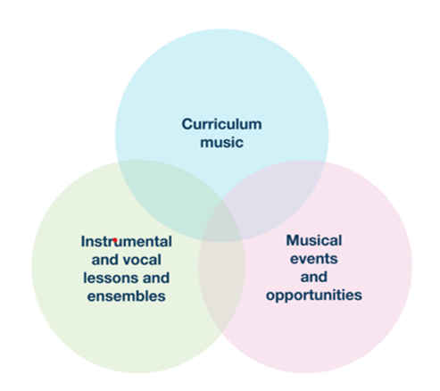

What is the area to improve? | Intent | Success Criteria | Implementation | Resources | Date | Impact
Curriculum | Staff knowledge of performance elements of the NC is further developed. | Staff access Year group specific performance CPD which are accessed as part of planning. | Music Lead signpost staff to accessible CPD videos, ensuring all staff know how and why to access. | Showbie  CPD videos | November 2026
Curriculum | All staff delivering music to develop confidence in composing and notation. | Improved knowledge/ confidence of composition notation in staff and pupils | Lesson progression Sparkyard | Sparkyard | Summer 2027
Curriculum | All staff develop understanding of assessment in music. | Music is accurately assessed and drive ‘getting better’ at music through  secure and incremental learning of the technical, constructive, and expressive aspects of music, developing musical understanding. | Review approach in line with Sparkyard and implement developments through CPD with staff team. | Staff meeting time | Summer Term 2027
Instrumental and Vocal Lessons and Ensembles | Choir continues to be an established and valued aspect of KSM | Choirs are established and are accessed by disadvantaged and SEND pupils, including Key Stage 1 | Music Lead | Extra curricular club x 3 – Boyz Noyz, Songbirds, KS1 | Ongoing
Instrumental and Vocal Lessons and Ensembles | Rocksteady music tuition made available to interested families from EYFS-Y6 | Rocksteady assembly  Rock bands set up with interested pupils | Music Lead | Assembly  Timetabled slots as needed | Autumn Term 2026
Instrumental and Vocal Lessons and Ensembles | Strong links with NULC Performing Arts Centre provide our children with additional vocal/instrumental opportunities | Children at KSM have opportunities to access resources (including musicians) based at NULC Performing Arts Centre. | CB liaise with Performing Arts staff to explore and plan possibilities. | Music Lead time  Staffing for visits. | Spring Term 2027
Musical Events and Opportunities | Yearly program of events at KSM is planned with SLT | All children participate in a minimum of 3 x yearly concerts. | SLT plan yearly calendar for musical opportunities. | SLT meeting | September 2026
Musical Events and Opportunities | Live Music events are planned and booked with SLT | All children experience a minimum of 1 x live music event in school. | Music Lead explores opportunities and books live music events. | Music Lead time | ongoing
Musical Events and Opportunities | Wider opportunities for musical experiences are developed. | Strong links with NULC Performing Arts Centre raise awareness and promote musical progression routes into adult life. | Music Lead liaises with NULC to plan opportunities for visits. | Music Lead time/ NULC staff time | ongoing
Musical Events and Opportunities | Wider opportunities for musical experiences are developed. | Community links are strengthened and provide children with performance opportunities e.g Mill Rise, church | Music Lead continues to liaise with community leaders to ensure opportunities are maximised. | Music Lead time | ongoing
Communication activities | All stakeholders are aware of musical provision and opportunities at KSM. | Parents, LGC and other stakeholders have awareness of the value that KSM holds in the lives of our children. They are informed about music at KSM and attend performances. | Music is celebrated and highlighted through Class Dojo and Facebook | Music Lead/ Admin time | Throughout year.

