
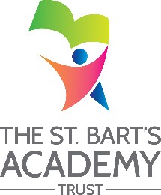
The St. Bart’s Academy Trust
Knutton St Mary’s CofE Academy
Local Governing Committee Attendance Record

Current Attendees
 |  | Autumn Term  2024  (Business LGC) | Autumn Term  2024 | Spring Term  2025 | Summer Term  2025 | Autumn Term  2025  (Business LGC) | Autumn Term  2025 | Spring Term  2026 | Summer Term  2026
Governor Name | Notes | 18th September 2024 | 27th November 2024 | 19th March 2025 | 9th July 2025 | 24th September 2025 | 19th November 2025 | 18th March 2026 | 24th June 2026
Anne Gadsden |  | √ | √ | √ | √ | √
John Alessi |  | × | × | √ | √ | √
Sue Sidebottom |  | × | √ | √ | √ | √
Amy Buckley |  | √ | √ | √ | √ | -
Jayne O’Brien |  | √ | × | √ | √ | √
John Collier |  | √ | √ | √ | √ | ×
Jennifer Craig |  | √ | √ | √ | √ | √
Linda Jones |  | √ | √ | √ | × | -
Charlotte Copeland |  | × | × | × | × | ×

Previous Attendees
Governor Name | Notes

