

Knutton, St. Mary’s Academy Whole School Provision Map
Tier 1 - High Quality Learning | Tier 2 – Guided / Group Intervention | Tier 3 – Personlised Support
High quality, inclusive teaching and learning which takes into account the learning needs of all the children in the classroom. This includes providing reasonable work, scaffolds for learning and adjusted outcomes.  KSM pupil entitlement:  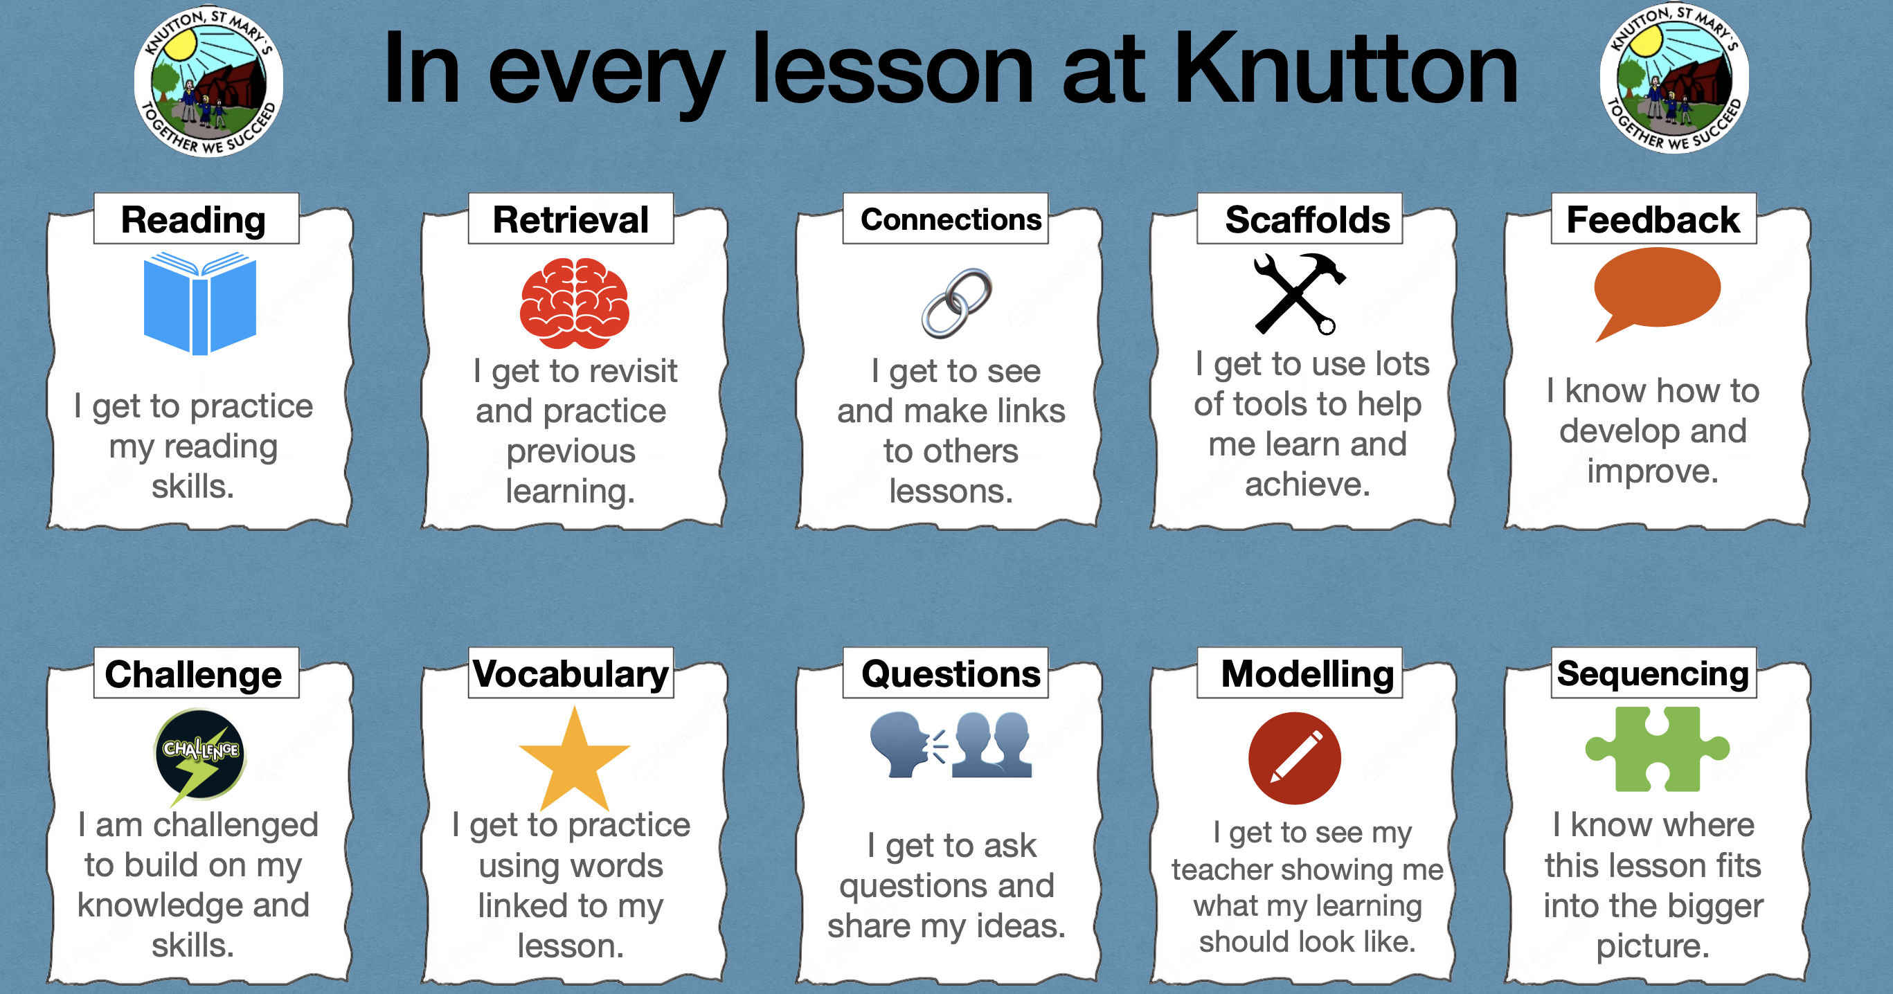  - Additional processing time  - Afterschool clubs  - Breakfast club available each morning providing extended social opportunities  - Playground and Reading Buddy systems  - iPads  - Adjusted outcomes/scaffolded planning  - Group work  - Key words/word banks/sentence stems  - Lunchtime clubs  - Modelled interaction  - Modelled speech/language  - Kapow PHSE lessons  - Residential experiences/trips/wow days  - School council  - Sequencing activities  - Simplified language  - Structured school and class routines  - Talk partners  - Targeted questioning  - Transition support from EY-KS1, KS1-2 and KS2 to high schools  - Visual class timetable/aids in classrooms  - Whole class circle time | Targeted provision describes specific, additional and time-bonded interventions provided for some children who need help to accelerate their progress to enable them to work at or above age-related expectations. This support/intervention is targeted to children who are not making the expected progress through the universal provision. Some children’s needs may also be being supported through involvement of external agencies. Children may be on the SEND Register at SEN Support level or Specialist SEND Support.  KSM reasonable adjustments pupil entitlement:  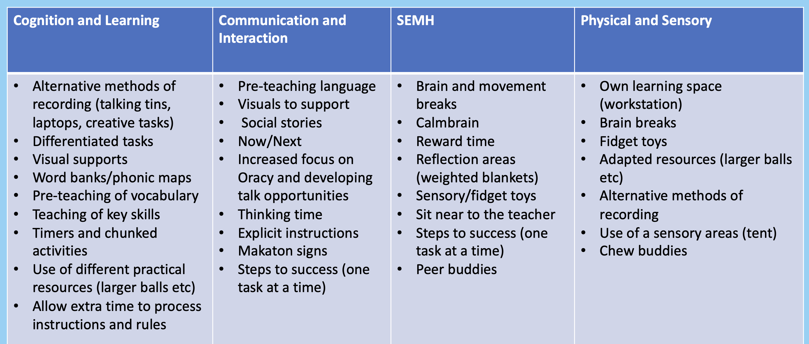  - Pivots for Cognition and Learning needs  - Boxall Profiles for SEMH needs  - ELSA and emotion coaching interventions  - 1:1 reading and Reading Lab (reading ambassadors)  - Additional phonics sessions  - Personal Support Plans for pastoral and behaviour strategies  - Individual Learning Plans with identified targets  - Nessy – Literacy support for Dyslexia  - Precision teaching  - Personalised visual timetable / resources  - Mastery maths  - EP Literacy approach for reading and spelling intervention  - Sensory audits and Coventry scale audits  - Colourful semantics  - Interventions planned by teachers to meet specific gaps | Personalised provision describes targeted provision that is needed for a few children where it is necessary to provide highly tailored intervention to accelerate progress and/or enable children to achieve their potential. This may include one-to-one or specialist interventions. Children will be on the SEND Register at either SEND specialist support level or may require statutory assessment/have an EHCP.  - Educational Psychologist (EP)  - Behaviour support SLA (Entrust)  - SBMAT SEND specialist observations and reports to inform ILPs and outreach pathways  - CAMHS referrals/Caudwell referrals  - GP/paediatrician  - Makaton  - Outreach support (e.g. The Meadows, Cicely Haughton, VIP Education, Caudwell’s)  - Personalised individual timetables/resources  - Regular speech and language therapy  - Specialist equipment and resources e.g. sensory equipment  - The Den (sensory and experiential learning resource base)  - Speech and Language Therapy (SALT)  - Structured speech and language programmes  - Targeted intervention and regular consultation with outside agencies  - Raised at Staffordshire SEND hub – RAG rated approach to support  - Family Action / Action for Children referrals  - Occupational Therapy/Physiotherapy  - Emotion Coaching 1:1/Counselling Services

