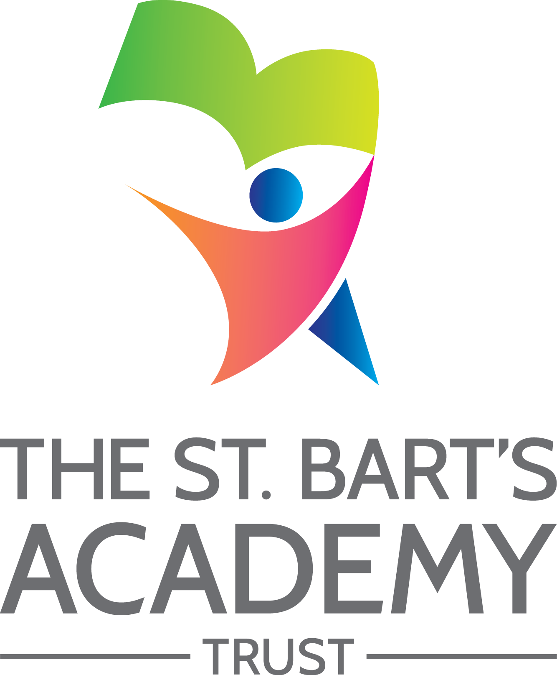

Knutton St. Mary's CofE Academy

Accessibility
Plan

October 2024

The St. Bart’s Academy Trust
Accessibility Plan
Date | Section Amended | Signature
01/03/2023 | TSB Policy Adopted – v4 | S. Jones

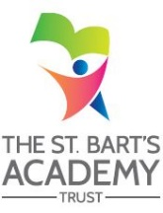

Contents

Statement of intent 4
1. Accessibility Plan – 2024 / 2025 5
2. Planning Duty 1: Curriculum 6
3. Planning Duty 2: Physical Environment 7
4. Planning Duty 3: Information 8

Statement of intent
This plan outlines how Knutton St. Mary's CofE Academy aims to increase access to education for pupils with disabilities in the three areas required by the planning duties in the Equality Act 2010 (i.e. the curriculum, physical environment and information).
A person is regarded as having a disability under the Equality Act where they have a physical or mental impairment that has a substantial and long-term adverse effect on their ability to carry out normal day-to-day activities.
This plan aims to:
- Increase the extent to which pupils with disabilities can participate in the curriculum.
- Improve the physical environment of the school to enable pupils with disabilities to take better advantage of education, benefits, facilities and services provided.
- Improve the availability of accessible information to pupils with disabilities.
The above aims will be delivered within a reasonable timeframe, and in ways which are determined after taking into account pupils’ disabilities and the views of parents and pupils. In the preparation of an accessibility strategy, the LA will have regard to the need to allocate adequate resources in the implementation of this strategy.
The governing committee also recognises its responsibilities towards employees with disabilities and will:
- Monitor recruitment procedures to ensure that individuals with disabilities are provided with equal opportunities.
- Provide appropriate support and provision for employees with disabilities to ensure that they can carry out their work effectively without barriers.
- Undertake reasonable adjustments to enable staff to access the workplace.
- The plan will be resourced, implemented, reviewed and revised in consultation with:
- Pupils’ parents.
- The principal and other relevant members of staff.
- Governors.
- External partners.

- Accessibility Plan – 2024-2025
Our Accessibility Plan sets out how this Academy will improve equality of opportunity for disabled people. This plan sets out the establishment’s proposals to increase access to education for disabled pupils in the following three areas:
- Increasing the extent to which disabled pupils can participate in the curriculum on an equal basis with their peers;
- Improving the physical environment of the establishment to enable disabled pupils to take better advantage of education and associated facilities and services; and
- Improving the availability of accessible information to disabled pupils.
The preparation of the Accessibility Plan has been informed by audits and analyses of data within the Academy and its premises. It is a requirement that the Accessibility Plan is resourced, implemented and reviewed as necessary and at least annually. A copy of this Plan together with the SBMAT Accessibility Policy will be placed upon our website.
This plan will be reviewed on an annual basis by the Local Governing Committee and Principal. Any changes to this plan will be communicated to all staff members and relevant stakeholders.

- Planning Duty 1: Curriculum
Issue / Action | Lead Responsible | Identified Budget  and any other resources | Target Date | Success Criteria
Incorporate High Quality Learning pupil entitlement into all teaching and learning throughout the whole curriculum. | SLT | CPD time | Ongoing | All pupils are exposed to High Quality Learning meaning that they make at least expected or in some cases, accelerated progress.
To continue to involve as many children as possible in extra -curricular activities. | SLT |  | Ongoing | Greater numbers of children attending after school clubs.
To ensure all children have the opportunity to take part in educational visits. | Class Teachers |  | Ongoing | Clear overall view of where each year group will visit and how opportunities are mapped out to ensure equality of opportunity with clear links to a range of curriculum areas.
Resources are prepared and provided to support pupil’s access to the curriculum. This could include visual timetables, now and next cards and other scaffolding materials. | Class Teachers |  | Ongoing | All pupils make at least expected progress. Barriers to learning are removed enabling pupils to access all aspects of the curriculum.
Review all school policies and schemes of work to ensure inclusion of disability issues and specific needs. | SLT | Release Time | Ongoing | All areas of school policy to reflect DDA and are specific to the school and the needs of the pupils.
Personalised ILP’s for SEN Support and EHCP pupils, which involve pupils and parents in collaborative working to set SMART targets to ensure expected progress is achieved. | Class Teachers / SENCO | Release time | Ongoing | Regular analysis of data ensures that pupils who may not make expected progress are identified and actions taken to accelerate progress

- Planning Duty 2: Physical Environment
Issue / Action | Lead Responsible | Identified Budget  and any other resources | Target Date | Success Criteria
Liaison with Staffordshire SEND Hub (Occupational Therapy, Physiotherapists, SALT, Dyslexia Training, School Counsellor, MHST, CAMHS) to ensure children have equipment, aids and any skills / tools they can use specific to their needs. | SLT | Cost of equipment, training and release time. | Ongoing | Children will have appropriate equipment relevant to their needs and skills.
To improve the physical environment of the school to enable all children, families and wider community to access the school and its facilities. | Principal and Premises Office | Cost of maintenance and adaptations | Spring 2024 | School is viewed as a welcome, encouraging establishment where we offer support and promote multi agency working.
To give consideration to the physical environment in any school development plans – including installation of visual aids equipment and hearing equipment. | SLT and Premises Officer | Cost of equipment, installation and maintenance. | Ongoing | Access to a broad and balanced curriculum for all children.

- Planning Duty 3: Information
Issue / Action | Lead Responsible | Identified Budget  and any other resources | Target Date | Success Criteria
Showbie to be used by children, staff and parents regularly as point of information for all involved in the child’s education.  Staff email also available to parents. | All Staff |  | Ongoing | Parents informed daily about children’s progress / areas of concern / areas for development.  Continue to improve parental contact.
Termly parents evenings with all parents attending.  Better record system put in place, so that teachers can keep a log of which parents do and do not attend (particularly persistently the latter). | Class Teachers |  | Ongoing | All parents attend parents evening and are aware of strengths and areas for development.
Information available on school website including all school letters, school policies and useful website links.  (paper copies of school policies are available on request).  Showbie, school website and Facebook page used to keep parents informed and up to date with information.  Information is accessible to all. | All Staff | Release time | Ongoing | Information more readily available by accessing school website.  Parents receive all necessary information about up and coming events at school through a range of means; newsletters, letters, information posted on Class Dojo, websites, texting, emails and social media.  Parents and wider community able to access information more readily.

St. Bart’s Multi-Academy Trust
c/o Belgrave St. Bartholomew’s Academy,
Sussex Place, Longton, Stoke-on-Trent, Staffordshire, ST3 4TP
www.sbmat.org T: 01782 486350

