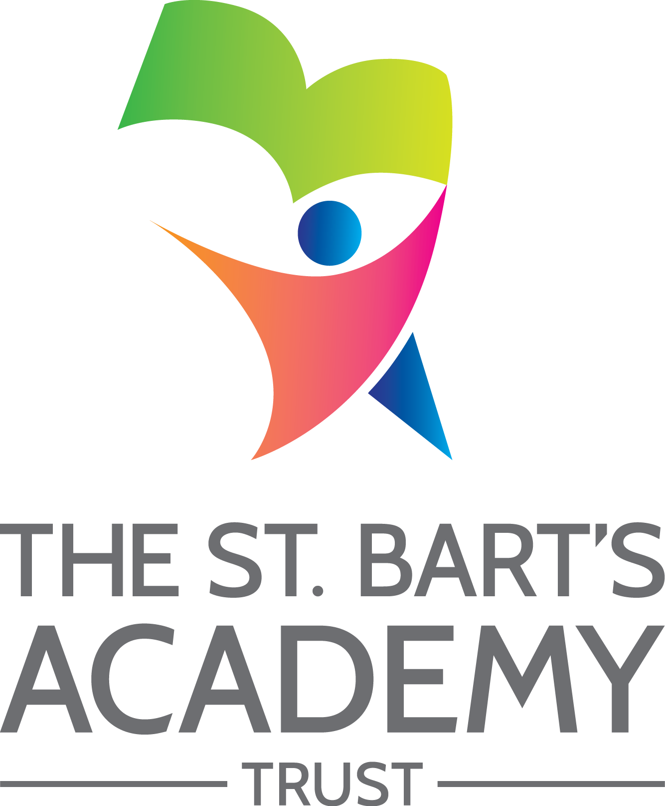

School Uniform
Policy

March 2023

The St. Bart’s Academy Trust
School Uniform Policy
Produced Date: |  | March 2023
Approved by Trust Board: |  | 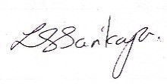 | Lisa Sarikaya  Chief Executive Officer
Review Date: |  | March 2025
Date | Section Amended |  |  | Signature
February 2023 | Section 1 – Legal Framework |  |  | S. Cope
February 2023 | Section 4 – Equality Principles |  |  | S. Cope

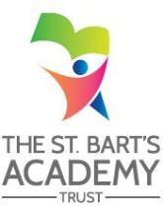

Contents

Statement of intent 4
1. Legal framework 5
2. Roles and responsibilities 5
3. Cost principles 6
4. Equality principles 7
Gender 7
Religion and belief 7
Race 8
SEND and medical conditions 8
5. Complaints and challenges 8
6. School uniform supplier 8
7. Uniform assistance 9
8. Non-compliance 9
9. School uniform 9
School colours 9
Clothing 9
Jewellery 11
School bag 11
Hairstyles 11
Makeup 11
10. Adverse weather 11
11. Labelling 12
12. Monitoring and review 12

Appendix 1 - School Uniform Assistance Application Form 13

Statement of intent
St Bart’s Multi-Academy Trust believes that a consistent school uniform policy is vital to promote the ethos of the school and provide a sense of belonging and identity for all pupils, regardless of their protected characteristics or socio-economic circumstances.
For the purposes of this policy, “uniform” includes the following elements of pupils’ appearance:
- Clothing, including the school uniform itself, variations of the school uniform such as PE kits, and other clothing worn at school, e.g. non-uniform.
- Hairstyles and headwear.
- Jewellery and other accessories.
- Cosmetics such as makeup and nail polish.
This policy lays out the measures the school has taken to ensure a consistent, fair and inclusive uniform policy, and to implement a uniform that reflects the needs of all pupils, and is affordable and the best value for money for the school and pupils’ families.
We believe that pupils learn most effectively and achieve their best outcomes when they are comfortable, able to be themselves, and dressed in such a way that sets an appropriate tone for education.

- Legal framework

This policy has due regard to all relevant legislation, including, but not limited to, the following:
- Education and Inspections Act 2006
- Education Act 2011
- Human Rights Act 1998
This policy has due regard to all relevant legislation and guidance including, but not limited to, the following:
- Human Rights Act 1998
- Education and Inspections Act 2006
- Equality Act 2010
- Education Act 2011
- The UK General Data Protection Regulation (UK GDPR)
- Data Protection Act 2018
- Education (Guidance about Costs of School Uniforms) Act 2021
- DfE (2021) ‘Cost of school uniforms’
- DfE (2021) ‘School Admissions Code’
- DfE (2021) ‘School uniforms’
- Equality and Human Rights Commission (2022) ‘Preventing hair discrimination in schools’

- Roles and responsibilities

The LGC is responsible for:
- Establishing, in consultation with the principal and school community, a practical and smart school uniform that accurately reflects the school’s vision and values.
- Ensuring that the school’s uniform is accessible and inclusive, and does not disadvantage any pupil by virtue of their protected characteristics or socio-economic status.
- Listening to the opinions and wishes of parents, pupils and the wider school community regarding changes to the school’s uniform.
- Ensuring that the school’s uniform is accessible and affordable.
- Demonstrating how best value for money has been achieved in the uniform policy.
- Ensuring compliance with the DfE’s ‘Cost of school uniforms’ guidance.
- Processing and approving all eligible School Uniform Assistance Application Forms.
The Principal is responsible for:
- Enforcing the school’s uniform on a day-to-day basis.
- Ensuring that teachers understand this policy and what to do if a pupil is in breach of the policy.
- Listening to the opinions and wishes of the school community in regard to the school’s uniform and making appropriate recommendations to the governing board.
- Providing pupils with an exemption letter as appropriate, e.g. for a pupil who has a broken arm and requires a loose-fitting top.
Staff members are responsible for:
- Ensuring that pupils dress in accordance with this policy at all times.
- Ensuring that pupils understand why having a consistent and practical school uniform is important, e.g. school identity.
Parents are responsible for:
- Providing their children with the correct school uniform as detailed in this policy.
- Informing the Principal if their child requires a more relaxed uniform policy for a period of time, including why.
- Ensuring that their child’s uniform is clean, presentable and the correct size.
Pupils are responsible for:
- Wearing the correct uniform at all times, unless the Principal has granted an exemption.
- Looking after their uniform as appropriate.
- Understanding and respecting why a school uniform is important to the school, e.g. school identity and community.

- Cost principles
The school is committed to ensuring that its school uniform is affordable and accessible to all pupils, and does not place an unreasonable financial burden on parents.
In accordance with the ‘School Admissions Code’, the Principal will ensure that the school’s uniform policy does not discourage parents from applying for a place for their child.
The school will assess the overall cost implications of its uniform policy regularly, including prior to making any changes to the school uniform. When evaluating whether costs are reasonable and proportionate, the school will take into account the opinions and situations of:
- Economically disadvantaged parents.
- Parents with multiple children who are, or will be in the future, pupils at the school.
- Parents of younger children, as they are likely to grow quickly and require new sets of uniform more frequently.
- Parents of pupils with protected characteristics that may impact their ability to access the uniform due to costs.
- LAC and PLAC.
The school will evaluate the cost of its uniform based on the overall collection of uniform items that parents would need to purchase for a pupil, rather than on the cost effectiveness of individual items; this will include consideration of the fact that parents will need to purchase multiples of certain items, e.g. shirts and socks, to ensure their child can come to school in clean uniform every day.
The school keeps variations in school uniform for different groups of pupils, e.g. year group-specific items or house colours, to a minimum where possible to ensure that pupils can get the most wear out of their uniform possible and that parents can pass some items down to younger siblings.
The school keeps branded uniform items to a minimal level that is reasonable for all members of the school community. The school defines a branded uniform item as any item of clothing that cannot be purchased at a range of retailers, e.g. supermarkets, due to the item’s logo, colour, design, fabric or other unique element..
Where the school requires an item of branded clothing, it will assess how prices can be kept as low as possible and put measures in place to facilitate this. This may include:
- Offering sew- or iron-on logo patches for blazers and jumpers that can be bought at non-specialist retailers, instead of requiring specific branded jumpers.
- Ensuring branded items are longer-lasting and unlikely to be grown out of quickly, e.g. ties.
- Making donated second-hand uniform available for purchase at a lower price
The school is committed to meeting the DfE’s recommendations on costs and value for money. Every care is taken to ensure that our uniforms are affordable for all current and prospective pupils, and that the best value for money is secured through reputable suppliers.
The school works with multiple suppliers to obtain the best value for money possible. Any savings negotiated are passed to parents where possible and does not enter into exclusive single supplier contracts or cash-back arrangements. More information on supplier processes can be found in the ‘School uniform supplier’ section of this policy.
The school will not amend uniform requirements regularly and will take the views of parents and pupils into account when considering any changes to school uniforms.

- Equality principles
The school takes its legal obligation to avoid unlawfully discriminating against any protected characteristic very seriously. In line with this, the school will aim to ensure that its uniform policy is as inclusive as possible so that all pupils can access a school uniform which is comfortable, suitable for their needs, and reflects who they are, while avoiding any direct or indirect discrimination on the basis of protected characteristics or socio-economic status.
The school will ensure that parents and pupils are consulted over any changes to school uniform, and that views and advice is sought specifically from pupils, and parents of pupils, who:
- Are transgender, including non-binary pupils.
- Have SEND and/or sensory needs.
- Are of a religious or cultural background that has dress requirements.
Parents’ concerns and requests regarding school uniform and amendments to it are handled on a case-by-case basis by the Principal and Local Governing Committee, and always in accordance with the Trust Complaints Procedure.
Information on how the school ensures its uniform policy does not discriminate against pupils with specific protected characteristics is outlined below.

Gender
To avoid disproportionately impacting pupils of a certain gender, the school will ensure that the cost of uniform is as equal in price as possible across items for all genders.
This includes:
- Adhering to the procedures laid out in the ‘Cost principles’ section of this policy.
- Not directly requiring pupils of a certain gender to buy additional uniform, e.g. by requiring female pupils to buy both trousers and skirts.
- Not indirectly requiring pupils of a certain gender to buy additional uniform, e.g. by offering football in PE to only male pupils and requiring they buy football boots to participate.
- Not holding pupils of different genders to different uniform standards, e.g. by banning certain hairstyles for only one gender.
The school will implement a gender-neutral uniform, meaning that pupils will not be required to wear specific items based on their gender, and may wear any of the uniform items listed in the ‘School uniform’ section of this policy regardless of the legal sex recorded on the school’s records. Transgender pupils are supported to access the uniform that best reflects their gender expression.

Religion and belief
To avoid disproportionately impacting pupils of a certain religion, belief or culture, the school will ensure that there is flexibility to allow pupils to present themselves in a way that adheres to their dress requirements as far as possible, within the school’s uniform policy.
The school will endeavour to meet all requests for amendments to the uniform for these purposes; however, the needs and rights of individual pupils will be weighed against any health and safety concerns appropriate to the circumstances, e.g. if safety headgear needs to be worn.

Race
To avoid disproportionately impacting pupils of a certain race, the school will ensure that its uniform policy does not constitute unlawful indirect discrimination through blanket rules. This includes:
- Not banning hairstyles related to a pupil’s ethnic origin, e.g. natural Afro hairstyles.
- Not banning hairstyles worn because of cultural, family and social customs, e.g. cornrows.
- Not banning head coverings related to a pupil’s culture or ethnic origin, e.g. African heritage head wraps.
The school will follow the good practice guidance provided by the Equality and Human Rights Commission on ‘Preventing hair discrimination in schools’.

SEND and medical conditions
To avoid disproportionately impacting pupils with SEND or medical conditions, the school will ensure its uniform policy takes into account the needs of these pupils. This includes:
- Ensuring the school uniform uses soft, stretchy fabrics and avoids intricate buttons or hard seams.
- Allowing variations to the standard uniform for pupils whose medical conditions may impact how they dress, e.g. pupils with casts who require loose-fitting clothing or pupils with hair loss-related conditions who wish to wear head coverings.
Where the needs of these pupils cannot be met in the standard uniform policy, individual adaptations to the uniform will be considered and permitted wherever possible.

- Complaints and challenges
The school endeavours to resolve all uniform complaints and challenges locally and informally, in accordance with the Trust Complaints Procedure.
To make a complaint, parents should refer to the Complaints Procedure and follow the procedures outlined.
When a complaint is received, the school works with parents to arrive at a mutually acceptable outcome.
Governors are willing to consider reasonable requests for flexibility to allow a pupil to accommodate particular social and cultural circumstances.

- School uniform supplier
Our current school uniform supplier is:
- Smart Uniform: Harvey House, Hassell St, Newcastle-under-Lyme, Newcastle ST5 1AR
- http://www.smartuniform.co.uk/
- Tel: 01782 713650
Our school uniform supplier accepts school uniform assistance vouchers.
The Local Governing Committee (LGC) will ensure that a written contract is in place with the supplier for branded items.
The school will retender the uniform contract every five years, whether changes to the uniform are made or not, in line with the Tendering and Procurement Policy. The LGC will be able to demonstrate how uniform is procured at the best value for money. The Principal will work to ensure that the items are procured as cheaply as possible without compromising on the quality, e.g. by requesting standard-style items from the supplier rather than more intricate and unique designs.
The school does not sign contracts with suppliers before requesting visualisations of proposed uniform, as well as fabric samples.
Where the school is proposing to change suppliers, it will reach out to suppliers by October in the determination year.

- Uniform assistance
The school supports vulnerable families in meeting the costs of uniforms. School uniform assistance is provided via a voucher worth £26 that can be spent on school clothing. The budget for the school uniform assistance scheme will be derived from pupil premium funds.
To claim school uniform assistance, parents should be eligible for FSM. Eligibility is determined by checking original documents from the relevant authority, detailing receipt of the benefit and the address of the pupil.
Families who meet the criteria should complete the School Uniform Assistance Application Form and return it to the school office.
The school holds second-hand school uniforms in the school office for parents to access; access to these uniforms is available upon request made to the Principal. Parents are invited to donate their child’s uniform when they no longer need it.

- Non-compliance
Staff members are permitted to discipline pupils for breaching this policy, in accordance with the school’s Behaviour Policy. Parents will be notified in all cases.

- School uniform

School colours
Our school colours are as follows:
- Red
- Blue
- Green

Clothing
The school uniform is as follows:
Item | Optional  or  required | Branding | How to acquire | Cost per item from school supplier
Regular school uniform
Navy Blue sweatshirt or Navy Blue cardigan | Required | School logo on right-hand side (iron-on school logo buttons available) | Branded sweatshirt and cardigan available from school supplier and second hand from school office. Black sweatshirt or cardigan can be bought from regular retailers. Iron-on logo buttons available from school office. | £14.00
White shirt/Polo Shirt | Required | No branding | Available from school supplier, second hand from school office and available from regular retailers. | £15.75/£7
School Clip on Tie | Required | No Branding | Available from School supplier | £6.95
Grey or black trousers or grey skirt | Required | No branding | Available from school supplier, second hand from school office and available from regular retailers. | £12.95
Sensible, plain black shoes | Required | No branding | Available from regular retailers. | N/A
PE kit
Plain white t-shirt | Optional | School logo on right-hand side | Available from regular retailers | £2
Plain black shorts | Optional | School logo on right-hand side | Available from school supplier and regular retailers | £5.25
Plain trainers | Required | No branding | Available from regular retailers | N/A
Accessories
School book bag | Optional | School logo | Available from school supplier. | £7.95

Pupils who are wearing skirts must also wear white socks/black tights.
Trainers are not considered suitable footwear. Heeled shoes and boots are not permitted; ankle boots are permitted.
Parents who do not wish to buy the optional branded PE kit must acquire a PE kit meeting the following criteria:
- Plain T-shirt with no branding or logos from professional sports teams
- Plain shorts or tracksuit bottoms with no branding or logos from professional sports teams
- Suitable trainers
- Suitable sports footwear, e.g. football boots
Parents are responsible for ensuring their child brings their PE kit to school when needed.

Jewellery
Permitted jewellery that may be worn is:
- One pair of stud earrings – no other piercings are permitted.
- A sensible wristwatch.
Jewellery is the responsibility of the pupil and not the school. Lost or damaged items will not be refunded. All jewellery must be removed during practical lessons, including PE lessons and science experiments.

School bag
Pupils must use an appropriately sized waterproof bag to carry their books and equipment.
School bags featuring inappropriate images, slogans or phrases are not permitted.
The school encourages pupils to bring non-valuable bags to school. The school will not be liable for lost or damaged school bags.

Hairstyles
The school reserves the right to make a judgement on where pupils’ hairstyles or hair colours are inappropriate for the school environment; however, will ensure that any such judgements do not discriminate against any pupil by virtue of their protected characteristics. Each individual pupil’s scenario will be taken into account where any judgements on appropriateness are to be made, and parents will always have the freedom to complain via the Trust Complaints Procedure.
Pupils with long hair must ensure that this does not impede their vision, cover their face or provide a health and safety risk. Long hair must be tied up during practical lessons, e.g. during PE.
The following hairstyles are not considered appropriate for school:
- Brightly-coloured, dyed hair.
- Lines and patterns shaved into the hair
- Headwear with bold patterns or colours.
- Excessive hair accessories.

Makeup
Make up is not permitted.

- Adverse weather
All pupils are required to wear weather-appropriate clothing that covers as much of their skin as possible during adverse weather.
For hot temperatures, this includes wearing:
- Loose-fitting and lightweight shirts and dresses with sleeves and collars or covered necklines.
- Knee length skirts, shorts or trousers.
Pupils are advised not to wear any jumpers during heatwaves. If outside during break times, pupils not wearing sun-safe clothing are advised to stay in an area protected from the sun.
For cold temperatures, this includes wearing:
- Scarfs, gloves, coats and hats when they are outside.
- Warm jumpers that conform to the school’s uniform policy.
- Trousers, or thick tights with skirts.

- Labelling
All pupils’ clothing and footwear is clearly labelled with their name.
Any lost clothing is be taken to the lost property box in the school office. All lost property is retained for one week and is disposed of if it is not collected within this time.

- Monitoring and review
This policy is reviewed every two years by the chair of governors and the Principal.

Appendix 1 - School Uniform Assistance Application Form
Children who attend name of school are eligible for school uniform assistance if they receive FSM.
This scheme is open to children in Years Reception to Year 6. The allowance is for buying suitable school wear and is paid once a year.
Part 1: Details of parent
Your full name:
Title:
National insurance number:
Address:
Postcode:
Phone no.:
Email address:
By supplying us with a phone number or email, you agree to being contacted to let you know if you are eligible.
Part 2: Details of each dependent child you are applying for
Surname | Other names | Date of birth
Please read this declaration before you sign it
- I declare I am the parent of the child(ren) that I am applying for.
- I declare that all the information I have given is correct and complete to the best of my knowledge.
- I have enclosed original documentation to prove that I am in receipt of one of the benefits listed at the top of this form.
- I am aware that I have a duty to notify the school in writing immediately of any changes in my circumstances which might affect my entitlement to school clothing assistance.
- I understand that information taken from this form will be stored electronically on the school’s computers. The school is permitted to do this under the UK GDPR and Data Protection Act 2018. A copy of the school’s registration is held for inspection.
Please return this completed for to the school office.
Your signature: ___________________________ Date: ____________________
What happens next?
If you apply for school uniform assistance and qualify, a voucher will be sent to you for each of your children during the week of date. If you do not qualify for the payment, we will let you know by letter and phone and explain why.

St. Bart’s Multi-Academy Trust
c/o Belgrave St. Bartholomew’s Academy,
Sussex Place, Longton, Stoke-on-Trent, Staffordshire, ST3 4TP
www.sbmat.org T: 01782 486350

