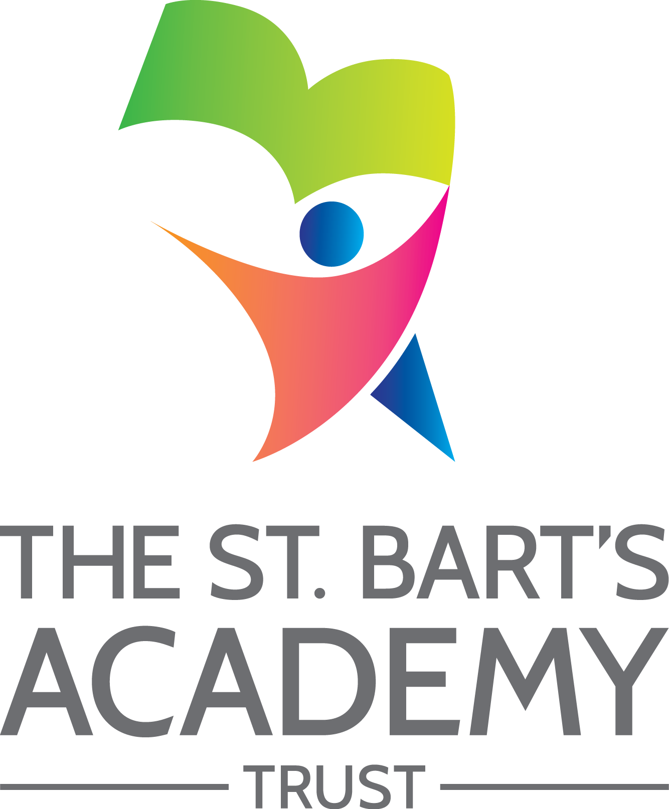

Freedom of Information Policy

September 2022

The St. Bart’s Academy Trust
Freedom of Information Policy
Produced Date: |  | September 2020
Approved by Trust Board: |  | 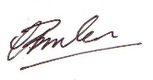 | Christopher Brislen  Chief Executive Officer
Review Date: |  | September 2022
Date | Section Amended |  |  | Signature

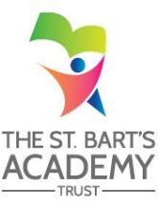

Contents

Freedom of Information Policy 4
1) Introduction: what a publication scheme is and why it has been developed 4
2) Categories of information published 4
3) How to request information 4
4) Paying for information 5
5) Information Currently Published 5
6) Feedback and Complaints 7

The St. Bart’s Academy Trust

Knutton St. Mary's CofE Academy

Freedom of Information Policy

This is the Knutton St. Mary's CofE Academy Publication Scheme on information available under the Freedom of Information Act 2000. The governing body is responsible for maintenance of this scheme.

1) Introduction: what a publication scheme is and why it has been developed
One of the aims of the Freedom of Information Act 2000 (which is referred to as FOIA in the rest of this document) is that public authorities, including all maintained schools, should be clear and proactive about the information they will make public.

To do this we must produce a publication scheme, setting out:

- The classes of information which we publish or intend to publish
- Whether the information is available free of charge or on payment
- The manner in which the information will be published

The scheme covers information already published and information which is to be published in the future. Some information which we hold may not be made public, for example personal information.

2) Categories of information published
The publication scheme guides you to information which we currently publish (or have recently published) or which we will publish in the future. This is split into categories of information known as 'classes'. The classes of information that we undertake to make available are organised into four broad topic areas:

- School Prospectus - information published in the school prospectus
- Governors' Documents - information published in the School Profile and in other governing body documents
- Curriculum - information about policies that relate to pupils and the school curriculum
- School Policies and other information related to the school (i.e. Academy Handbook) - information about policies that relate to the school in general

3) How to request information
If you require a paper version of any of the documents within the scheme, please contact the Academy by telephone, email, fax or letter. Contact details are set out below or you can visit our website at Choose an item..

Email: knuttonoffice@sbmat.org
Telephone: 01782568680
Contact Address: Church Lane, Knutton, Newcastle Under Lyme, ST56EB

To help us process your request quickly, please clearly mark any correspondence “PUBLICATION SCHEME REQUEST” (in CAPITALS)

If the information you are looking for is not available via the scheme and is not on our website, you can still contact the academy to ask if we have it.

4) Paying for information
Information published on our website is free, although you may incur costs from your internet service provider. If you do not have the internet, you can access our website through free Wi-Fi in public areas or a public library. Single copies of information covered by this publication are provided free unless stated otherwise. If your request means that we have to do a lot of photocopying or printing, or pay a large postage charge, we will let you know the cost before fulfilling your request.

5) Information Currently Published
Item | Description
School Prospectus | The statutory contents of the school prospectus are as follows, (other items may be included in the prospectus at the school’s discretion):  - information about the implementation of the governing body’s policy on pupils with special educational needs (SEN) and any changes to the policy during the last year  - a description of the arrangements for the admission of pupils with disabilities; details of steps to prevent disabled pupils being treated less favourably than other pupils; details of existing facilities to assist access to the school by pupils with disabilities; the accessibility plan covering future policies for increasing access by those with disabilities to the school
School Profile and other information relating to the governing body | The contents of the School Profile are as follows: list information included in the school profile e.g. performance data summary of Ofsted report school’s intentions for the future, etc.
Instrument of Government | - The name of the school  - The category of the school  - The name of the governing body  - The manner in which the governing body is constituted  - The term of office of each category of governor if less than 4 years  - The name of any body entitled to appoint any category of governor  - Details of any trust  - If the school has a religious character, a description of the ethos  - The date the instrument takes effect
Minutes ¹ of meeting of the governing body and its committees | Agreed minutes of meetings of the governing body and its committees [current and last full academic school year]  ¹Some information might be confidential or otherwise exempt from the publication by law – we cannot therefore publish this.
Academy Handbook | Details key information for staff on Belgrave St. Bartholomew’s Academy, including staff organisation, aims and procedures.
Accessibility Plan | Plan for increasing participation of disabled pupils in the school’s curriculum, improving the accessibility of the physical environment and improving delivery of information to disabled pupils.
Admissions Policy | Details information on the admissions process for Knutton St. Mary's CofE Academy and the criteria involved.
Behaviour Policy | Statement of general principles on behaviour and discipline and of measures taken by the head teacher to prevent bullying.
Charging and  Remissions Policies | A statement of the school’s policy with respect to charges and remissions for any optional extra or board and lodging for which charges are permitted, for example school publications, music tuition, trips.
Child Protection Policy | Statement of policy for safeguarding and promoting welfare of pupils at the school.
Complaints Procedure | Statement of procedures for dealing with complaints.
Data Protection Policy | This policy complies with the principles that are set out in the general data Protection Regulation (GDPR). It is to ensure that the Knutton St. Mary's CofE Academy and all staff who process or use any personal information follow these principles at all times.
Educational Visits Policy | Sets out guidelines that support the planning and implementation of educational visits organised by Knutton St. Mary's CofE Academy.
Equality Diversity | Equality, Diversity and Cohesion Policy that provides a framework to promote equality, promote positive attitudes and good relations between diverse backgrounds.
Exclusion Policy | Informs the school’s use of exclusion and the processes involved.
Freedom of Information Policy | This is the School Publication Scheme on information available under the Freedom of Information Act 2000.
Health and Safety  Policy | Statement of general policy with respect to health and safety at work of employees (and others) and the organisation and arrangements for carrying out the policy.
Home – school agreement | Statement of the school’s aims and values, the school’s responsibilities, the parental responsibilities and the school’s expectations of its pupils for example homework arrangements.
Published reports of Ofsted referring expressly to the school | Published report of the last inspection of the school and, where appropriate, inspection reports of religious education in those schools designated as having a religious character.
Record of Recruitment and Vetting Checks Policy | Clarifies the school’s position with regards to staffing, the recruitment and selection process, training and procedures, reference to applicable policies and the processes involved.
Safeguarding Policy | A policy which recognises of the school’s legal and moral duty to promote the well-being of children, in line with Section 175 of the Education Act 2002.
School session times and term dates | Details of school session and dates of school terms and holidays.
Sex and Relationships Education Policy | Statement of policy with regard to sex and relationship education.
Special Education Needs Policy | Information about the school's policy on providing for pupils with special educational needs.
Staff Discipline, Conduct and Grievance Policy | Statement of procedure for regulating conduct and discipline of school staff and procedures by which staff may seek redress for grievance.

6) Feedback and Complaints
We welcome any comments or suggestions you may have about the scheme. If you wish to make a comment, please pass this on to our Office Manager (contact details in section 3 above), who will inform the most relevant and appropriate member of the Senior Management Team. If you wish to make a complaint, please refer to our ‘Complaints Procedures’ policy, published on our website.

St. Bart’s Multi-Academy Trust
c/o Belgrave St. Bartholomew’s Academy,
Sussex Place, Longton, Stoke-on-Trent, Staffordshire, ST3 4TP
www.sbmat.org T: 01782 235524 F: 01782 235525

